St Mary’s Church, Billingsley: Events, July 2021
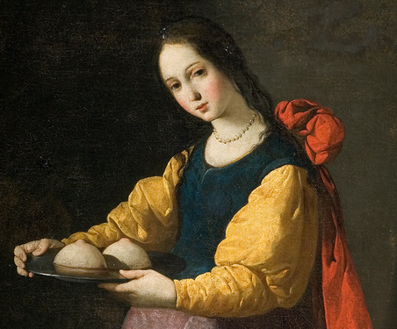
St Agatha, a woman of Billingsley Church

6.00pm Sunday 11th July; The Women of Billingsley Church
Billingsley Church has been shaped by women; come along to hear their stories

7.00pm Wednesday 21st July; A celebration of Billingsley Churchyard
We celebrate the spirituality of the natural world by focussing on our churchyard, using music, words and time for reflection.

12 noon Saturday 24th July; Auction for local churches, Chelmarsh Parish Hall
Please contact Bonnie Garvey (01746 552567/ yvonnegarvey2015@gmail.com or myself if you have any items you can donate for this.

8.00am Sunday 25th July; Holy Communion
A simple service of Holy Communion to start the day.

6.45pm Thursday 29th July; A walk around Chelmarsh
Meet outside Chelmarsh Church (easy parking!) for a walk around the reservoir and the common

David Poyner, assistant curate, Severn Valley Benefice. Tel 01562 68638/ 0121 204 3997; email D.R.Poyner@aston.ac.uk Follow us on Facebook https://www.facebook.com/BillingsleyChurch/ or our websites, www.st-marys-billingsley.org.uk , https://www.achurchnearyou.com/church/10415/

