St Mary’s Church, Billingsley, Events, May 2022
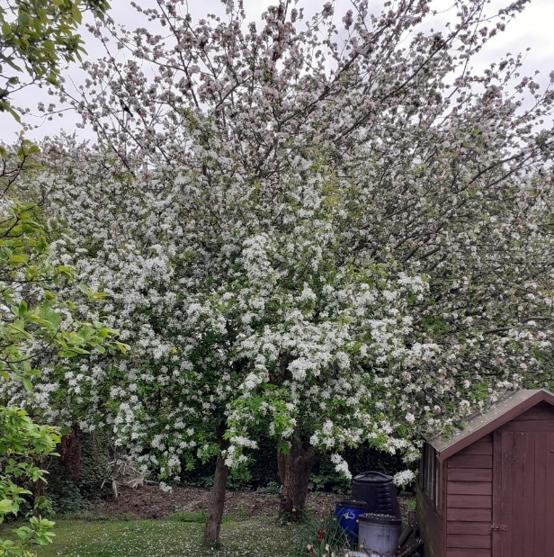
7.00pm Thursday 5th May, Billingsley Walk
Meet at Billingsley Church for a short walk to Bind Lane and back

A celebration of May Blossom: 6.00pm Sunday 8th May
An informal service featuring hymns, music and readings to fit with the season

Annual Parish Meeting: 7.00pm Tuesday 17th May
At Billingsley Church; anyone interested in knowing how we run the church is welcome.

3.00pm Saturday 21st May, Daddy’s Hat concert, GLAZELEY CHURCH
An hours’ worth of light music performed by local musicians, loosely themed around the tradition of the blessing of the crops and celebration of the fertility of the soil.

8.00am Sunday 22nd May, Holy Communion

10.00am Sunday 29th May, Benefice Service
We host our neighbours from Glazeley, Chelmarsh and Highley for a service of worship.

Friday 3rd June, from 2pm, Jubilee Community Picnic, Orchard next to the church
Bring a picnic, light refreshments available. Parking at Church Farm. Hosted by the 100 Club.

David Poyner, assistant curate, Severn Valley Benefice. Tel 01562 68638/ 0121 204 3997; email D.R.Poyner@aston.ac.uk Follow us on Facebook https://www.facebook.com/BillingsleyChurch/ or our websites, www.st-marys-billingsley.org.uk , https://www.achurchnearyou.com/church/10415/

