Billingsley and Glazeley Churches, April 2024

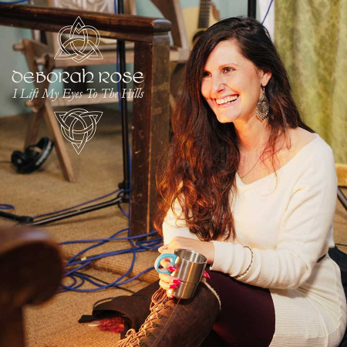

Sunday 14th April, 6.00pm, St Mary’s Billingsley; God and the Scientist. The assistant minister at Glazeley and Billingsley, David Poyner, is also a professional scientist, employed at Aston University, where he both teaches and does research into pharmacology, study of drug action. Here he will explain how he balances science and religious faith.

Saturday 20th April, 3.00pm, Daddy’s Hat Concert at Chelmarsh Church. We welcome Welsh singer Deborah Rose to Chelmarsh for an hour of her music; Deborah Rose – Official Website of Deborah Rose

Sunday, 21st April, 10am St Bartholomew’s Glazeley; Holy Communion
AND 2pm Afternoon Walk, Billingsley. Meet at the Cape of Good Hope for a walk around Billingsley. Route depends on the weather, there will be mud…

Sunday, 28th April, 8am St Mary’s Billingsley, Holy Communion

David Poyner, assistant curate. Tel 01562 68638 /0780 100 9693; email D.R.Poyner@aston.ac.uk Facebook https://www.facebook.com/BillingsleyChurch/ or websites, https://www.achurchnearyou.com/church/10415/ (Billingsley)/ Glazeley & Deuxhill: St Bartholomew - A Church Near You (Glazeley)

